

# SCHOOL OF SCIENCE AND TECHNOLOGY ACADEMIC SESSION APRIL 2022; WEB1201 WEB FUNDAMENTALS DEADLINE: 30 Sept 2022 (FRIDAY), 5:00 PM

**STUDENT NAME: Lester Koon Zhy Min - 20068813 NRIC/PASSPORT NO: 020919101789**

**INSTRUCTIONS TO CANDIDATES**

* This assignment will contribute 20% to your final grade.
* This is a group assignment, two students per group.

**IMPORTANT**

The University requires students to adhere to submission deadlines for any form of assessment. Penalties are applied in relation to unauthorized late submission of work. Coursework submitted after the deadline will be subjected to the prevailing academic regulations. Please check your respective programme handbook.

**Academic Honesty Acknowledgement**

“I ..................Lester Koon.............................(Name) verify that this

paper contains entirely our own work. I have not consulted with any outside person or materials other than what was specified (an interviewee, for example) in the assignment or the syllabus requirements. Further, I have not copied or inadvertently copied ideas, sentences, or paragraphs from another student. We realize the penalties *(refer to the student handbook diploma and undergraduate programme)* for any kind of copying or collaboration on any assignment.”

…………Lester – 7/10/2022................ (Student’s Signature / Date)

## **Webpage Design Report**

### **Brief introduction**

We were tasked to create an interactive webpage that can be sent as a ‘card’ to family, relatives and friends during a festive season. The festive season that we have chosen for this assignment is “Chinese New Year”.

### **Colour Scheme**

* The main colour scheme of this website is black with white and gold accent
* This core colour of black provides a modern and minimalistic look to the website which also signify quality, as seen in websites for luxury brands
* The white accent which is mostly on text, is in line with the minimalistic look whilst still providing a good contrast to the darker backgrounds. White is also a neutral shade which can be easily match with other colours
* The gold accent on the other hand is mostly used on important elements in the website. The gold is a warm and inviting colour which helps bring attention to the element/section it is highlighting. Gold is also a common colour that is closely related to the Chinese New Year festival, which represents glory, nobility, prosperity and good fortune.

### **Repeated elements**

#### **Navigation bar**

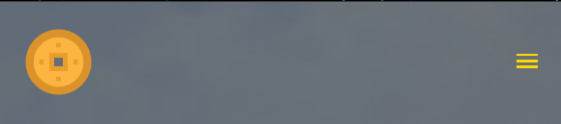

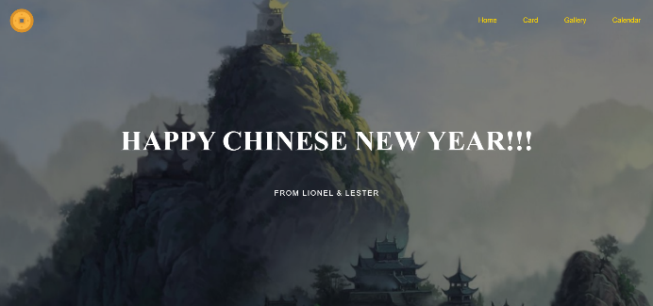

* The navigation bar is placed on the top of the page to ensure that the viewer is able to view the core information of the entire site before scrolling down
* It is present on every page and it contain links to other pages in the website.
* Clicking on each button including the logo while redirect the viewer to its respective pages with the logo redirecting to the homepage
* The background of the navigation bar is invisible, so it is able to blend better with the entire page to provide a more modern look
* The bar is also responsive to different screen sizes. The elements of the bar will collapse into a dropdown menu when the screen is reduced to a certain size. This prevents the bar from looking to cluttered whilst still maintaining its readability

#### **Footer**

* The footer has a simple design, which just provides information of the creators contact information
* The ‘E-mail’ component directly redirects the viewer to the corresponding email address

### **Homepage**

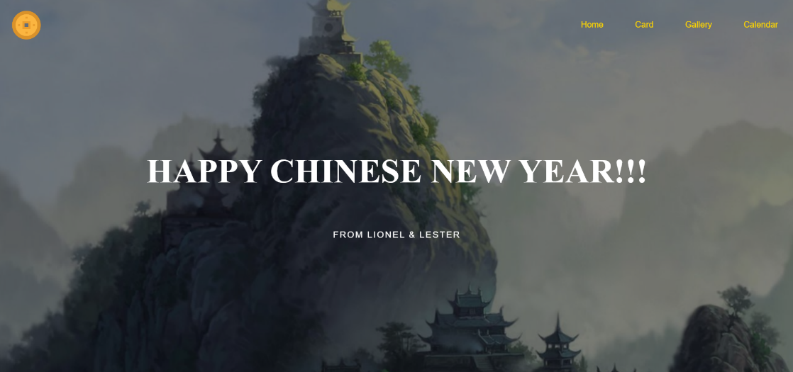

* The main homepage consists of the main objective of the website, which is a greeting for Chinese New Year, and a simple image background
* To help emphasize the greeting, it is placed at the horizontal and vertical centre of the page and the brightness of the background image is also decreased

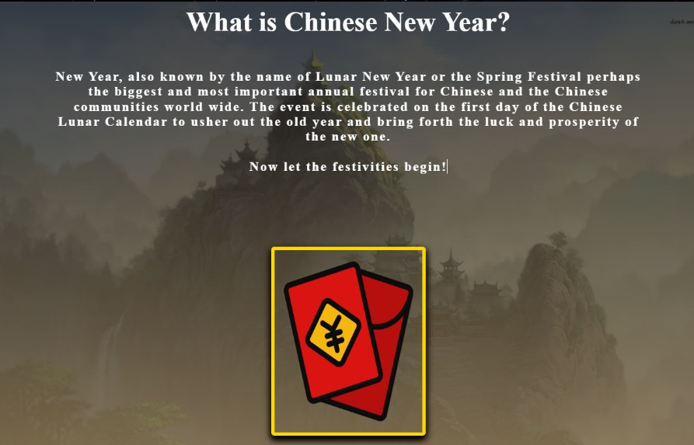

* This section of the provide brief information on the festival and a button which redirects the viewer to the card page
* The card button is placed there so the viewer would only click it after reading the information above
* The button has a gold border and a transform effect on hover, to help entice the viewer to click on it

### **Interactive card**

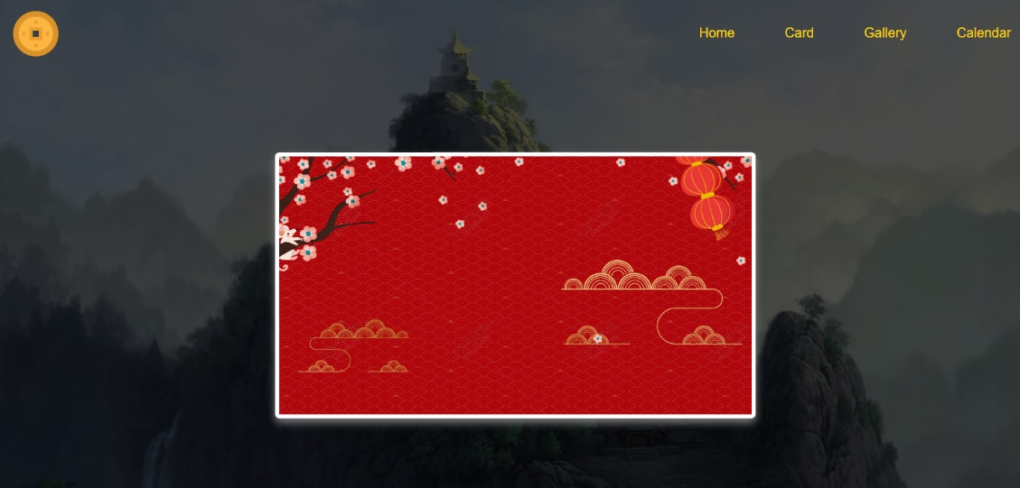

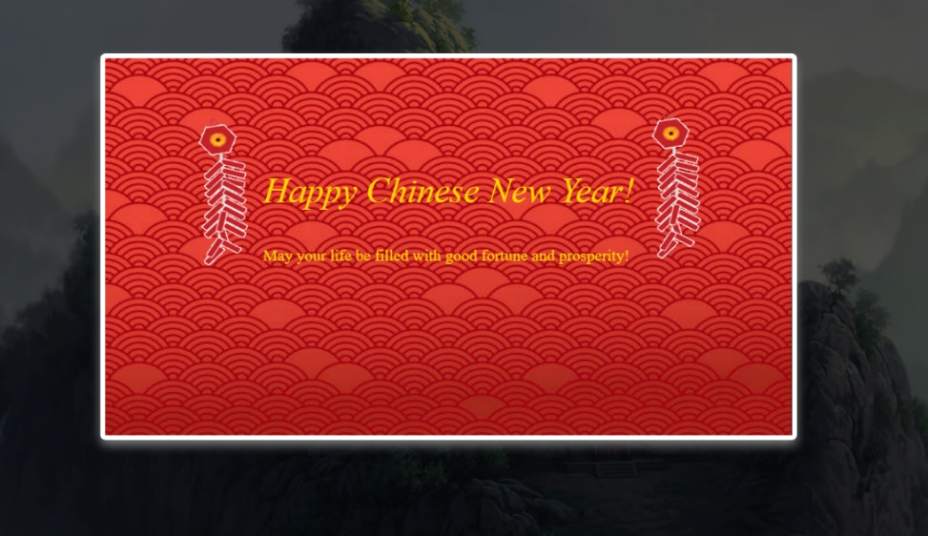

* This page consists of an interactive card for Chinese New Year
* The is on a separate ‘box’ to help represent a virtual card
* The front of the card is an empty background, which raises the viewers curiosity and urges them to click on it
* The card will open with a transition once the cursor hovers over it and closes back when the cursor is no longer there
* On the card is open an animation will be played once it is clicked on, this help draw more attention to the contents in the card and emphasises it

### **Traditions Gallery**

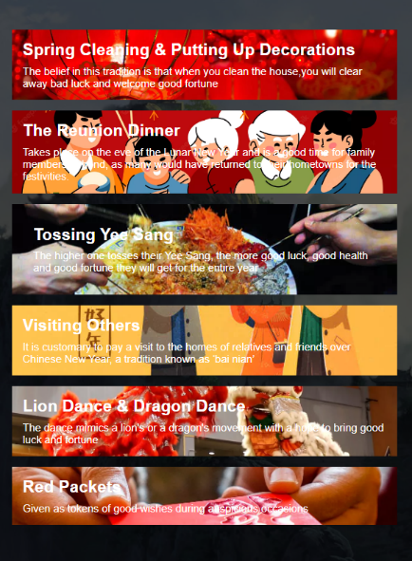

* This page provides information about the traditions of the festival
* A gallery is used instead of a text list, to make the page more attractive and encourages the viewer to read the information
* The layout of the gallery is design as such to ensure that each component receives an equal amount of attention from the viewer as no particular image is emphasised
* The gallery is also responsive to smaller screen sizes by changing its layout, to ensure that the text on each image is still legible

**Lunar Calendar**

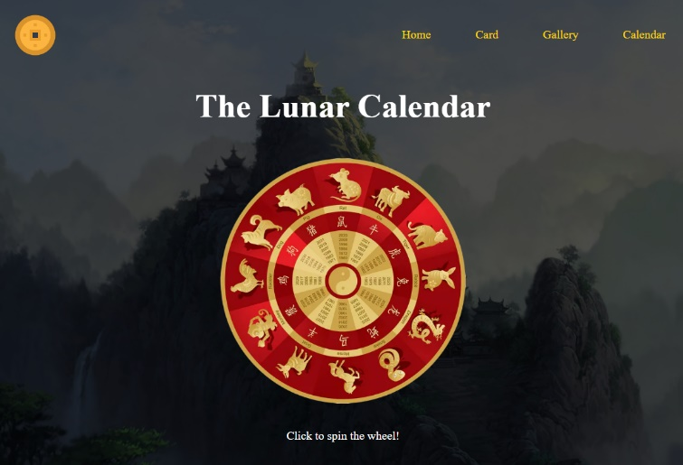

* This page consists of a lunar calendar, which helps denotes the zodiac signs for each Lunar New Year
* The calendar has an animation which rotates the calendar to the current year once it is clicked on. This helps the viewers identify the current zodiac sign without needing to read each section of the calendar individually

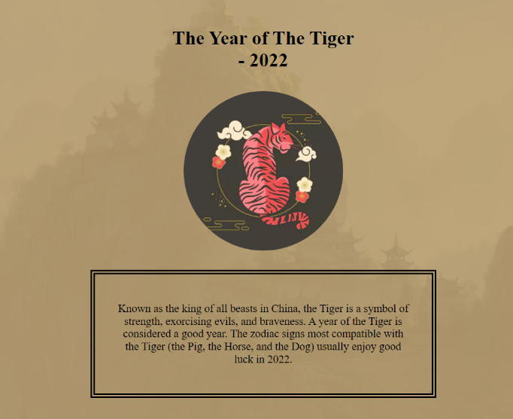

* This section of the page show information about the current zodiac sign
* The section is gold accented, to help emphasize the content on it
* The image of the tiger is placed at the centre, to make it the first thing the viewers see
* The text below is surround by a border, to help the viewer understand that the it is a single block of text that cannot be broken down into smaller snippets